**Task on VPC**

*Create VPC with 2 private and 2 public subnets*

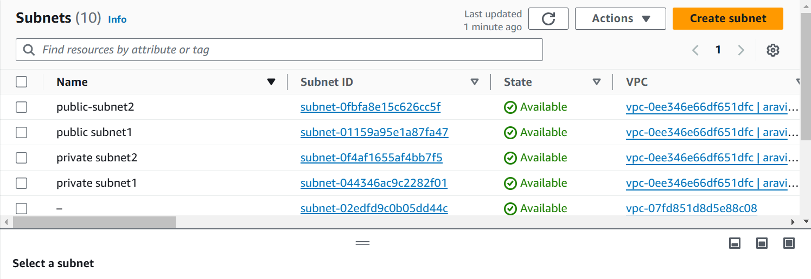

*Enable DNS Hostname in VPC*

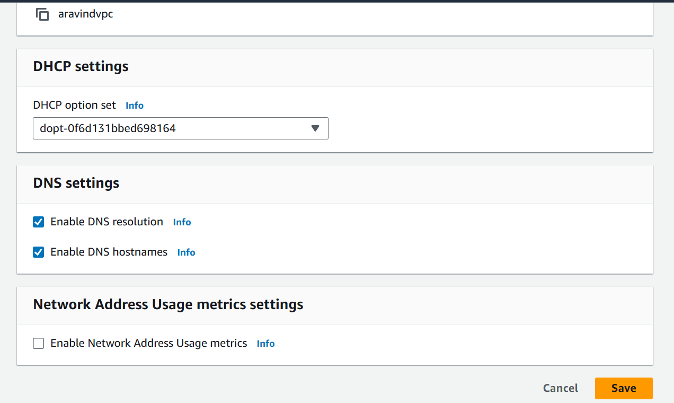

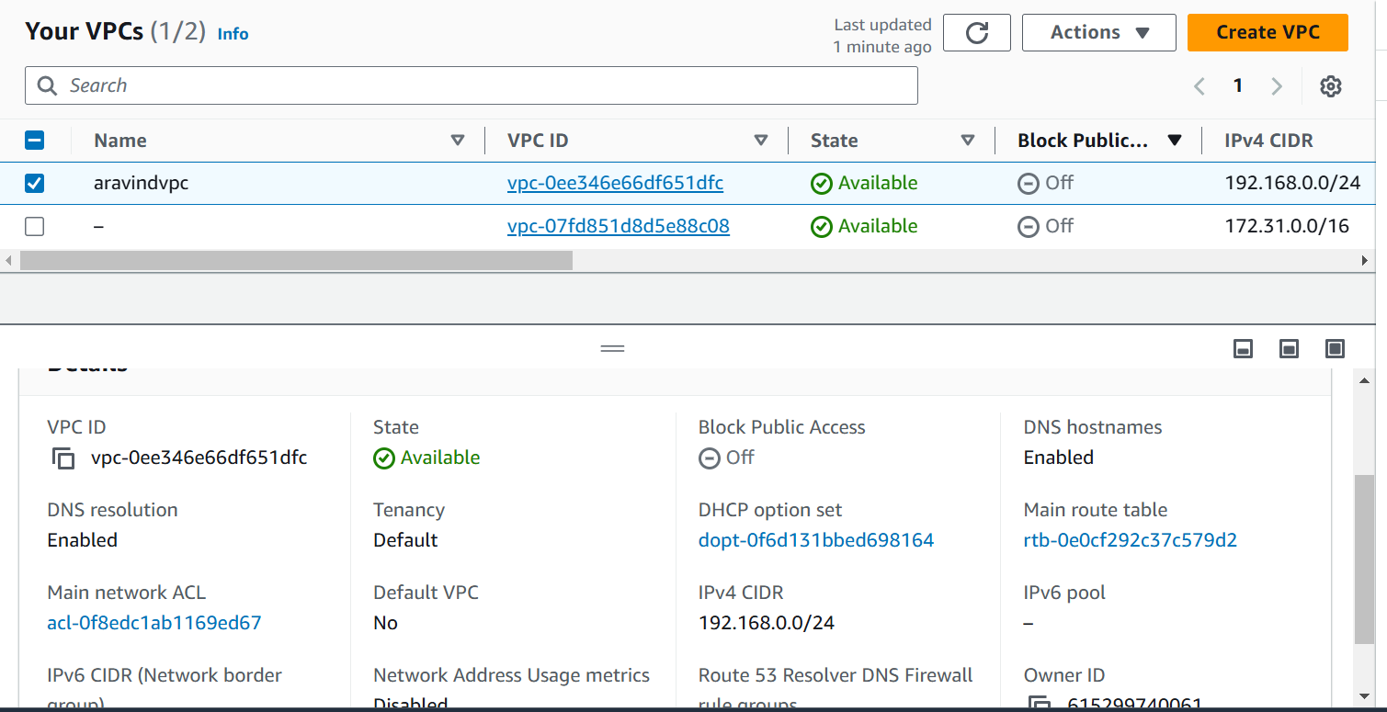

*Enable Auto Assign Public ip in 2 public subnets*

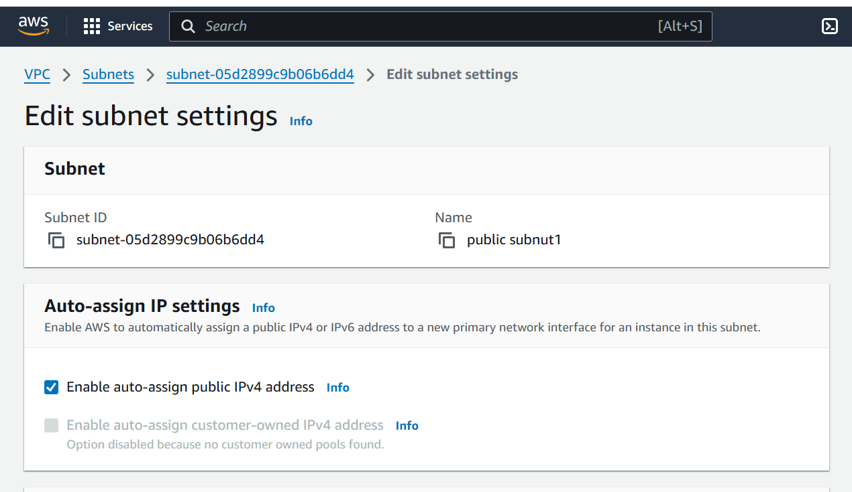

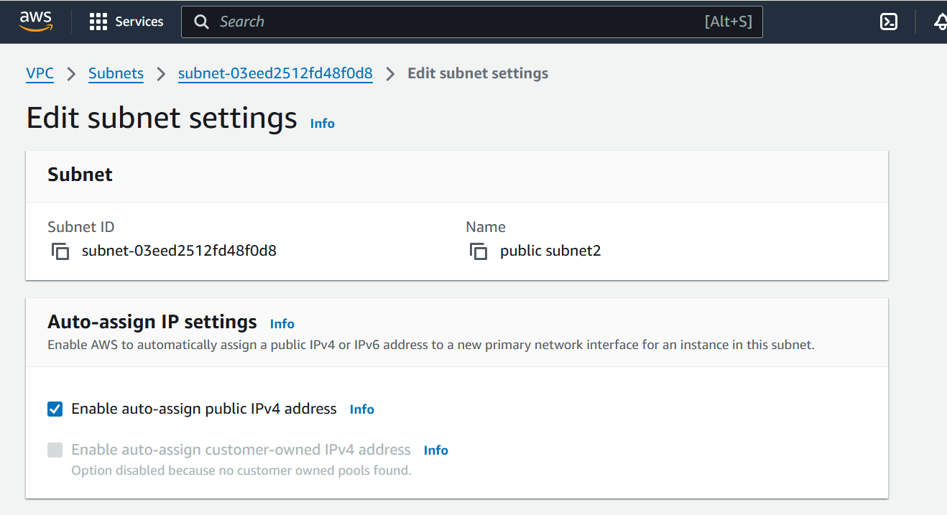

*Add 2 private subnets in private route table*

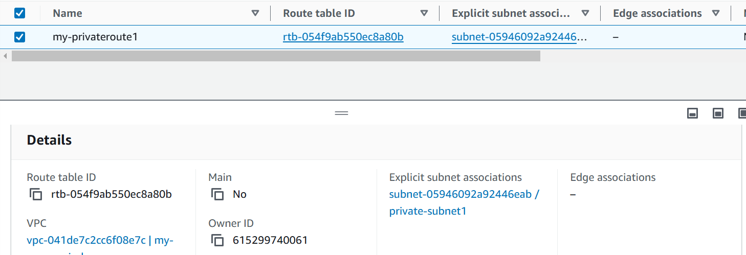

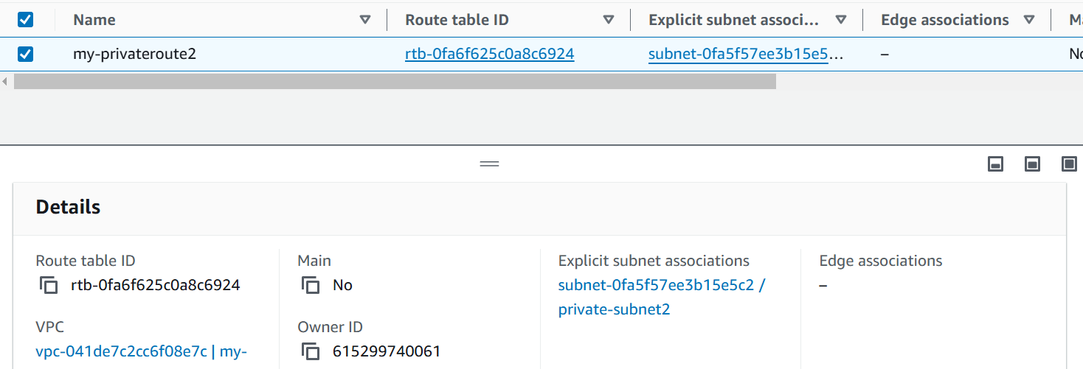

*Add 2 public subnets in public route table*

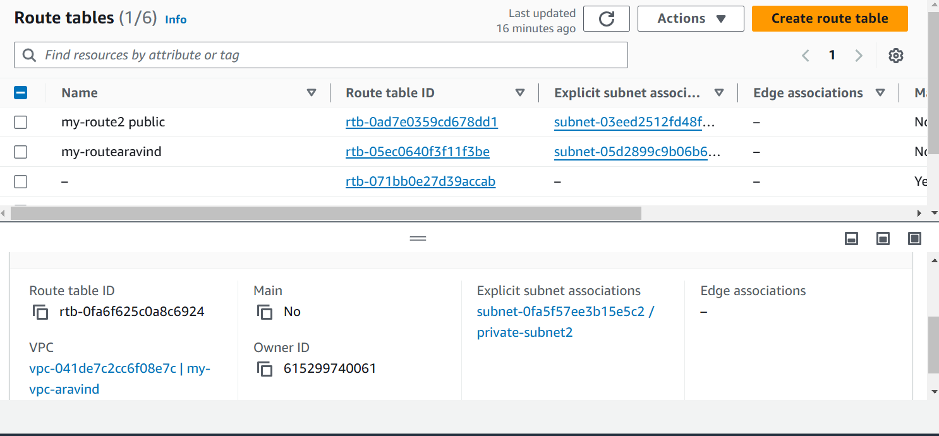

*Public route table will have the routes to internet and local*

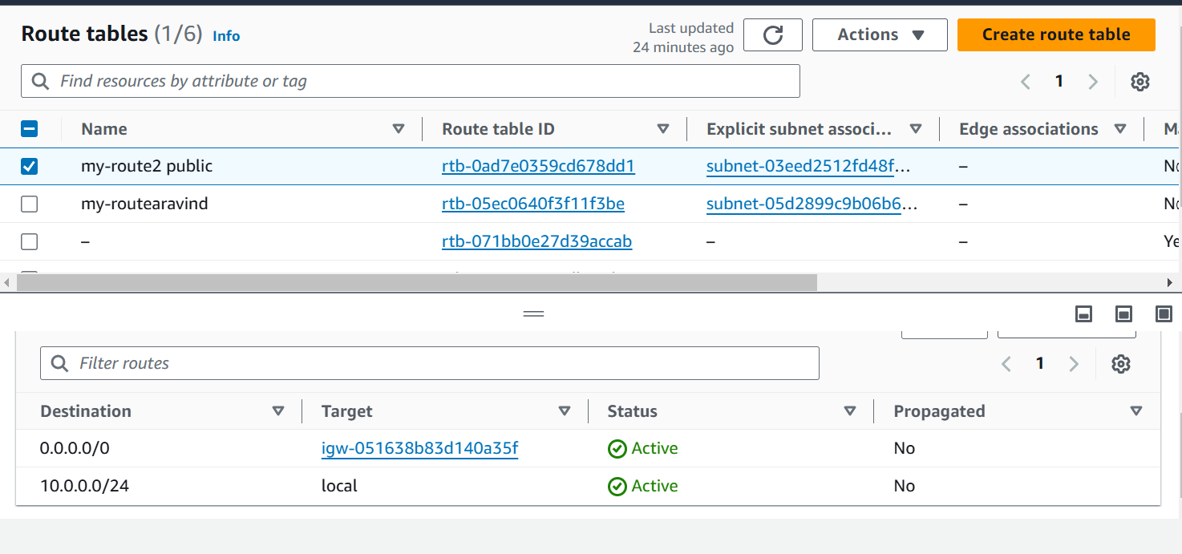

*Create Ec2 in public subnet with t2micro and install php*

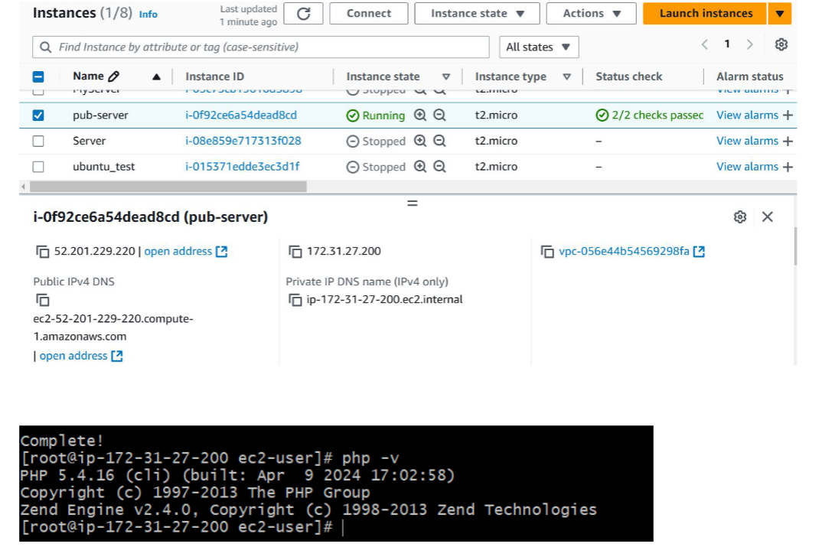

*COnfigure Nat gateway in public subnet and connect to private Instance*

